**How to recover from a corrupt IOS on Catalyst 2960**

1. Need to use xmodem over console cable.
2. Place copy of IOS on PC with console connection.
3. Connect with Hyperterminal, power on switch, and interrupt boot sequence by holding mode button.
4. Boots into monitor mode. Issue the **flash_init** command and the **load_helper** command.
5. Want to up the baud rate to speed up the transfer of IOS over serial cable. Issue the following command: set BAUD 115200
6. Restart Hyperterminal and connect with the new baud rate – 115200.
7. Issue the **copy xmodem: flash:filename** command on the switch.

Here is an example:

switch: copy xmodem: flash:c2960-lanbase-mz.122-35.SE5.bin

Begin the Xmodem or Xmodem-1K transfer now...CCC

1. From the top of the HyperTerminal window, choose Transfer > Send File.

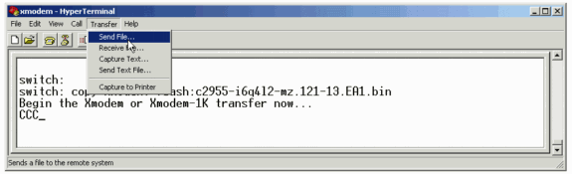

1. Choose the Xmodem protocol in the Send File dialog box and click Browse in order to select the Cisco IOS image (.bin file) that you downloaded previously.

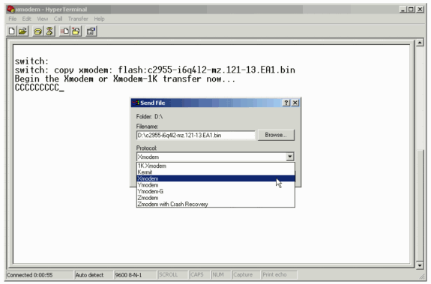

1. Click Send in order to begin the Xmodem transfer.

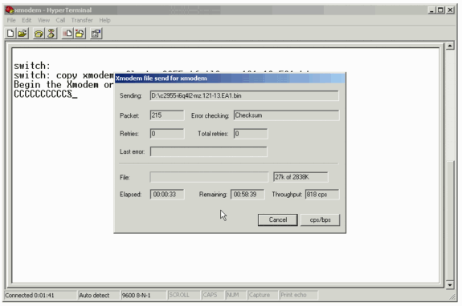

1. Boot the new image that you just copied over with the Xmodem procedure. Issue the **boot flash:filename** command, as this example shows:

switch: boot flash: c2960-lanbase-mz.122-35.SE5.bin

Loading "flash: c2960-lanbase-mz.122-35.SE5.bin"...############################### ################################################################################

!--- Output suppressed.

Press RETURN to get started!

Switch>

!--- The bootup was successful.

1. Be sure to verify that your boot statements are set correctly.

<http://www.cisco.com/en/US/products/hw/switches/ps628/products_tech_note09186a0080169696.shtml>